1

Financial Accounting

Summer 2026
This workbook contains copyrighted materials.
Please do not post them on any file sharing sites.

0. Accounting Foundation

0.1 Our Learning Purpose

Business acumen is the knowhow to operate effectively in business.

Financial literacy is the grasp of personal or corporate financial matters such as investing, saving, budgeting, compound interest, banking, equities and bonds, stock exchanges and portfolio diversification.

Accounting literacy is the ability to comprehend and communicate a financial situation or event, typically reflected by the ability to read a balance sheet and income statement.



Business acumen is supported by financial literacy, which is in turn underpinned by accounting literacy.

A lack of accounting literacy diminishes our financial literacy and business acumen.

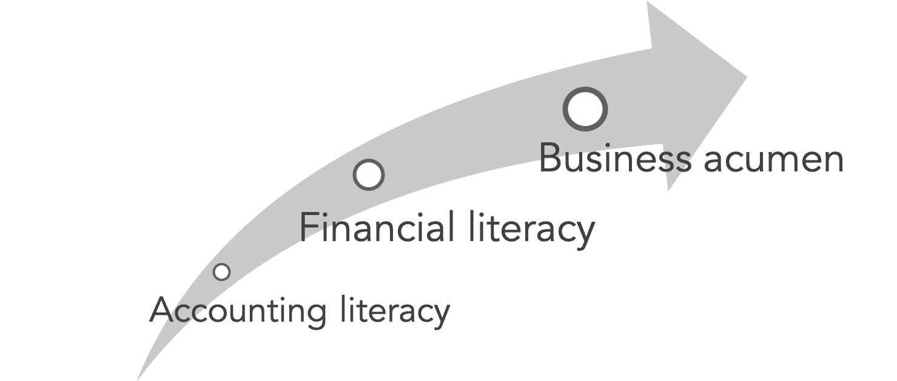

0.2 What is accounting?

When you strip away all the jargon, the procedures, the journals, the ledgers, the T-accounts, the balances...what is the essence of accounting?

It's simply a way of sorting. Specifically, sorting financial information. Grouping it so that we can make sense of it and make decisions based on it.

So, let's think about the concept of sorting.

What groups do we use? How many should we use?

And what about sub-groups within groups?

Are the groupings optional or absolute?

Think about the groups in your life distinguished by color, size, age, price, owner, type... the list is endless.

0.3 Perspective changes everything

- What is the key point of the “I want to buy a pineapple” story?
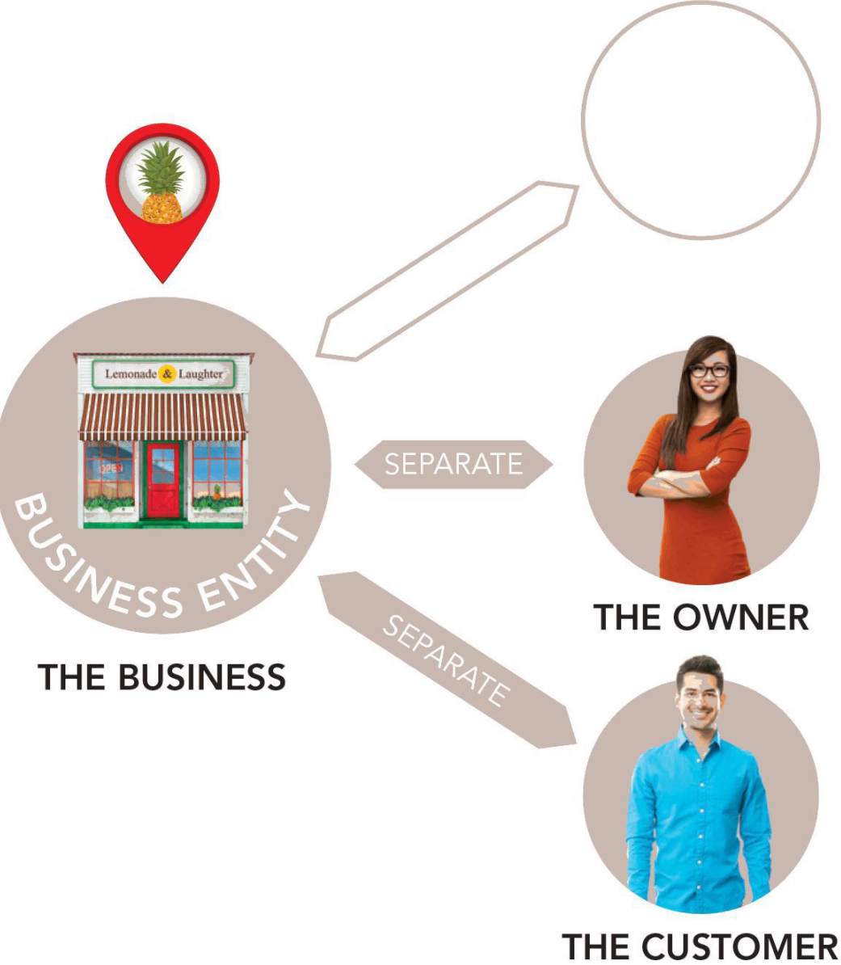


.

- What are two key elements or ingredients of accounting?

A____ and O____

- Can you elaborate more on the following statement “Accounting is a system for telling a story about someone’s assets and consequent obligations.”

1. Funding Butterfly

1.1 ASSETS
a. What is an asset? (In one sentence)

b. Give a few examples of Assets from the collection of assets below:


Figure 0. Assets, including some not traditionally found on a balance sheet

c. Probably you heard HR managers say that “people are our greatest assets”. Do you think “people” are really assets? (Yes or No).

d. What is purpose of sorting assets?

g. In order for an asset to be recorded on the balance sheet, it needs to pass two criteria called “Recognition Criteria”. What are those two criteria?



1.2 Discussion Questions
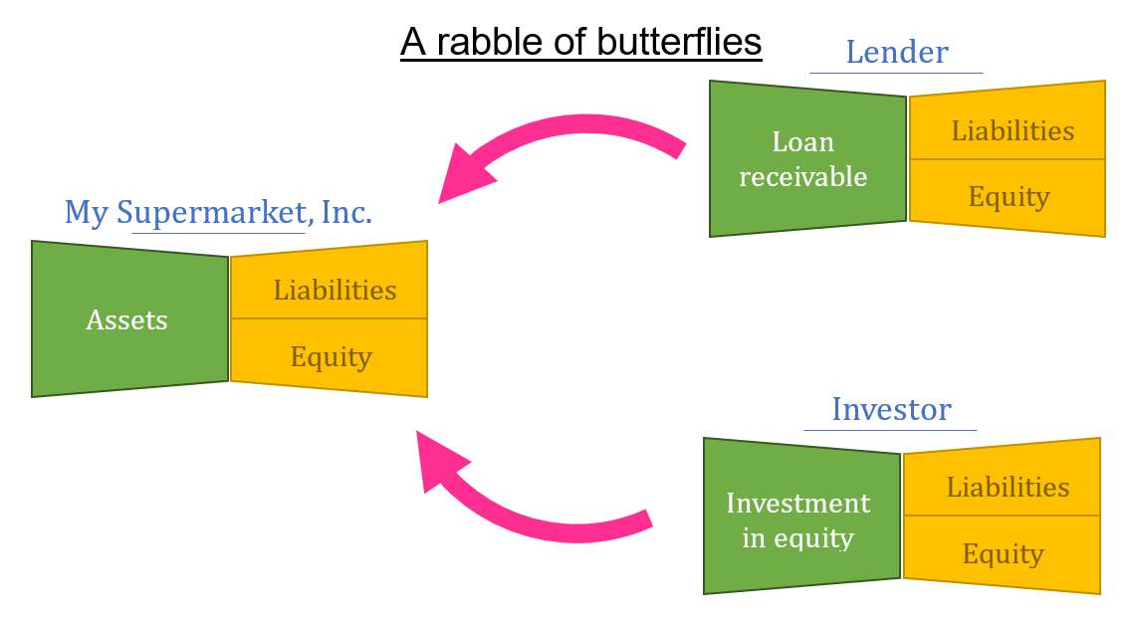

- What is a rabble of butterflies saying?

1.3 SOURCING ASSESTS
- When a business starts, it needs assets. How does the business acquire assets?

- Is it possible that a business can have more assets than its obligations?

- What is a simple definition of obligations?

1.4 ACCOUNTING DUALITY
- An entity can have only two things. Write those two things in the box?

- What is “Accounting Duality”?

- Is it possible that assets (or rights) and obligations can have different amounts? (Yes or No).

1.5 ACCOUNTING EQUAITON
- When we say, “Rights to Assets = Obligations”, does this mean assets and obligations are identical?

1.6 ACCOUNTING EQUAITON: BALANCE SHEET
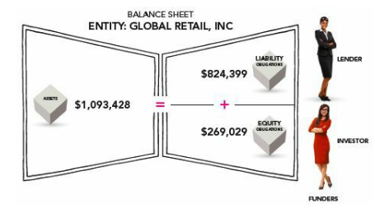
- Money vs. Currency Units
What do dollar signs stand for in the figure on the right?

- Sources and Uses of Funds. Fill in the blank
The accounting equation can be viewed as the story of funding business. To source funds for the business, the business incurs obligations. Obligations are _______________ of funds. And how do the funds show up or manifest? It shows up as money in the bank or in the form of other assets. So, assets are _______________ of funds. They are funds “in use”.

1.8 JOURNALING THE NEW BUSINESS

- What is a “journal” in business?

- What is a “journal entry”?

- Why will each transaction have two financial effects on assets, liabilities, or equity?

2. Accounting Framework – Deriving Profit

2.1 JOURNALING THE NEW BUSINESS
- Can you record the following two transactions in the butterfly box below?
L&L has $30,000 obligations to the lender (liability) and 2) $20,000 obligation to the investor (owner).

Balance Sheet of Lemonade & Laughter (L&L)
Assets
Uses of funds
Sources of funds
Liabilities
Equity
+
=

- Take a look at the figure below. What is the difference between contributed equity and generated equity (a.k.a. Retained earnings)?
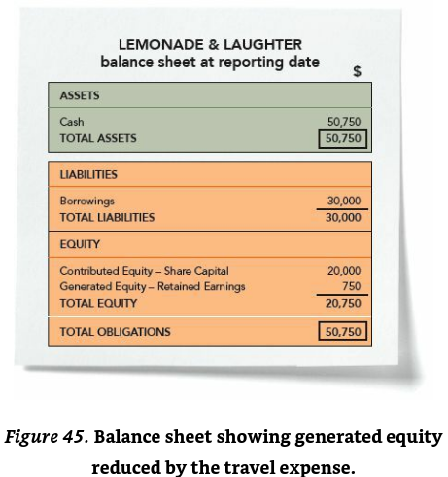

- Note that the retained earnings are not cash (or money). It’s an obligation that’s equivalent in size to a dollar amount (e.g., $750)

2.2 Unpacking Profit
- So far, all transactions are recorded in three-element butterfly box (Assets, Liabilities and Equity). In this section, the profit in equity section ($750) is expanded or unfolded further into 1) Revenue/income ($1,000) and 2) Expense ($250) in the purple box as below.
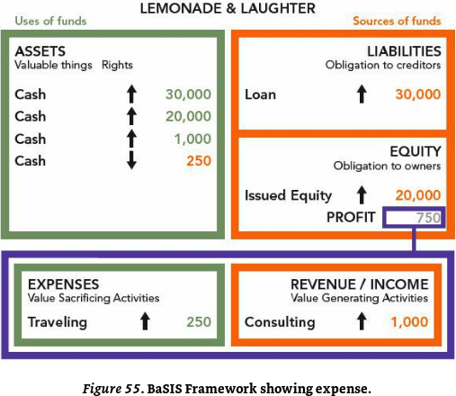
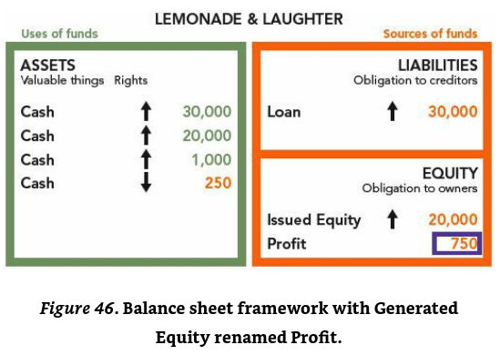

- What is the benefit of this five-element presentation (figure on the left) over the three-element presentation (figure on the right)?

- The purple box is known as Income statement as opposed to balance sheet.

- Why Revenue/Income is on the right-hand side in orange and Expense is on the left-hand size in green?

- There are only two elements in the income statement. What are they?

- The JOA (The Joy of Accounting) defines Revenue as “Value-Generating Activity” and Revenue is more of a verb concept.

- Is $1,000 revenue generated in the orange box cash?

- Can you give one example of revenue generating activities in any business you know?

- Revenue, Profit, and Income defined in different ways in different parts of the world.

- The JOA defines Expense as “Value-Sacrificing Activity”. However, the term “expense” is not necessarily “cash out” or “spend it”. It is also more of a verb concept.

- Yesterday, you paid $1 to acquire a note pad. And you teared up one piece of note pad (worth 1 cent) today. In this scenario, when did you incur “expense”? That is the act of paying $1 or tearing up a piece of note pad?

Discussion Points
- How does the income statement connect to the balance sheet?
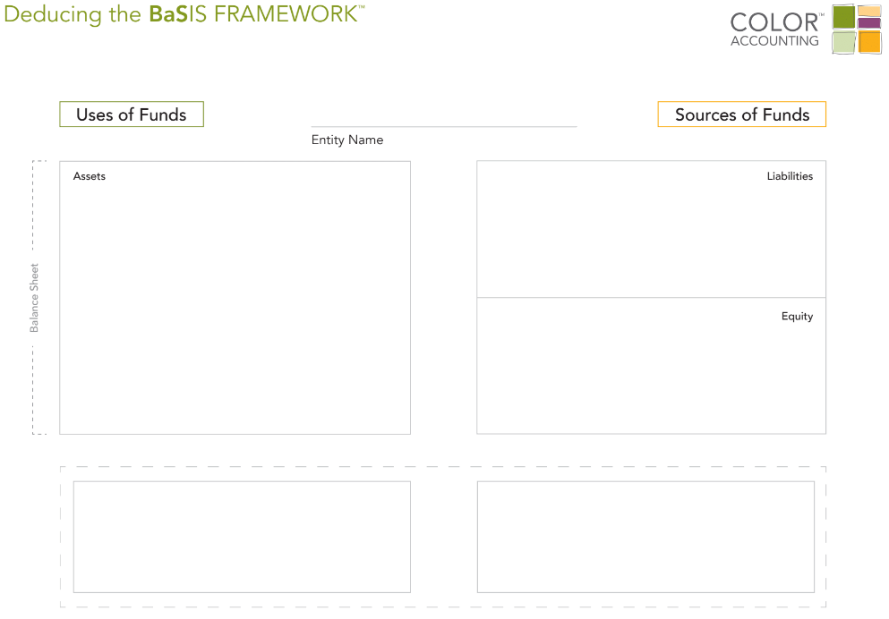
- State the educational definition of revenue.

- State the educational definition of expenses.

- Locate revenue and expenses in the Accounting (BaSIS) Framework™ model.

- Explain why the balance sheet is 'noun concepts' and the income statement is 'verb concepts'.

3. Classic Transactions

3.1 Analyzing Transactions – Review
Please indicate how each trasaction below affects different accounts of five accounting elements (Assets, Liabilities, Equity, Revenue and Expnese). Please indicate the dollar impact on each account with green and orange highlighers in the spreadhsheet below.

- On October 1, cash of $10,000 is invested in the business by investors, in exchange for $10,000 of Sierra Corporation common stock.
Cash (assets) increases by $10,000
Common Stock (equity) increases by $10,000
or
Cash $10,000
Common Stock $10,000

- On October 1, Sierra issued a 3-month, 12%, $5,000 note payable to Castle Bank.

- On October 2, Sierra purchased equipment by paying $5,000 cash to Superior Equipment Sales Co.

- On October 2, Sierra received a $1,200 cash advance from R. Knox, a client, for guide services for multi-day trips that are expected to be completed in the future.

- On October 3, Sierra received $10,000 cash from Copa Company for guide services performed for a corporate event.

- On October 3, Sierra paid its office rent for the month of October in cash, $900.

- On October 4, Sierra paid $600 for a one-year insurance policy that will expire next year on September 30.

- On October 5, Sierra purchased supplies on account from Aero Supply for $2,500.

- Hired four new employees with annual salary of $50,000 each.

- On October 20, Sierra paid a $500 dividend.

3.2 Analyzing Transactions – Review
Please indicate how each trasaction below affects different accounts of five accounting elements (Assets, Liabilities, Equity, Revenue and Expnese). Please indicate the dollar impact on each account with green and orange highlighers in the Jounral below.

Trip’s Business Services (E1-8B, Edmonds et al.)

Trip’s Business Services experience the following events during its first year of operations:
- On December 1, Acquired $20,000 cash from the issue of common stock.
- On December 1, Borrowed $12,000 cash from a bank to purchase land.
- On December 2, Paid $5,000 cash to purchase land. es Co.
- On December 2, Received $25,000 cash for provide boarding services.
- On December 3, Purchased additional land for $4,000 cash.
- On December 3, Paid $10,000 cash for salary expense.
- On December 4, Signed a contract to provide additional services (valued at $5,000) in the future.
- On December 5, Paid $1,200 cash for rent expense.
- On December 9, Customer A paid $10,000 cash for the future service in advance.

Activity 3.3 A review of 16 Classic Transactions
Below you will find 16 classic transactions we went over this week. Please review the same transactions one more time.
Recording transactions using journals
We didn’t use the term at the time, but the 16 Classic Transactions we saw during induction were “journals”. Here’s the first one:
In traditional journal form, this is how the transaction would be written:
Journal 1: 2 January
Increase in Cash at bank [assets] 30,000
Increase in Bank loan [liabilities] 30,000
- Every journal is numbered and dated.
- The first accounting entry is always the green ticket (debit) entry.
- The second line, the orange ticket (credit) entry, is usually indented.
- The last line sets out a brief description of the transaction.
The words in square brackets are not required, but it is suggested you do this so that you always think about where on the accounting framework each account sits.
In the exam, you are not be required to write the description.
 | Journals can be thought of as snippets of accounting code. By looking at a journal you can immediately see how a transaction is to be recorded in the accounting system.

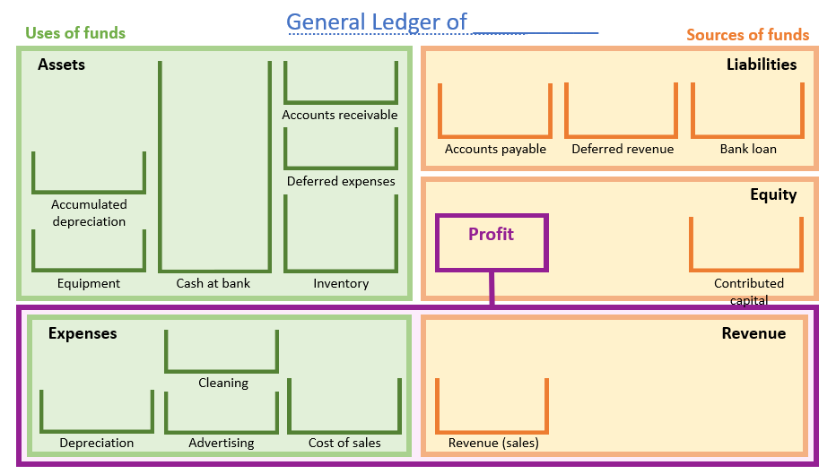
Now you have recorded all your transactions in the journal. Can you tell me the ending balance of each accounts? You will have to transfer (post) all your 16 transactions recorded in your journal to the accounts below. You should use different color for green and orange tickets.

4. Summary

Activity 4.01 Summary

- Draw and label the Accounting (BaSIS) Framework.

- Write out both forms of the accounting equation.

- Use the notes pages that follow to reflect and comment on this topic:
- In your own words, explain what you have learned.
- What, if anything, are you still confused about?

- Create a question you think the professor might ask (e.g., in exam) and include what you believe to be the correct response.

