3. Introducing Financial Accounting (Ch 1)
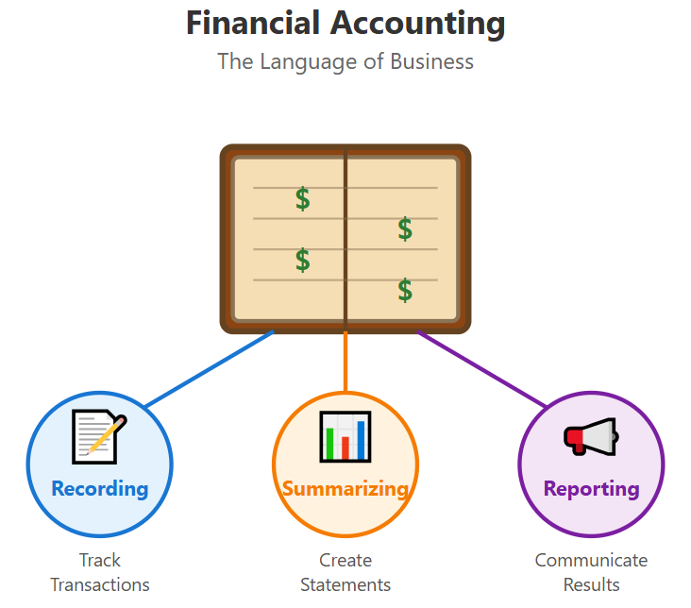

Table of Contents
3.1 Demand For Accounting Information 2
Users of Accounting Information 2
Forms of Business Organization 3
Supplies of Information 4
3.2 Business Activities 5
3.3 Financial Statements and Accounting Duality 5
Accounting Duality : Assets = Obligations in a Balance Sheet 6
Perspective Changes Everything 7
Entity Concepts 7
How the Income Statement Flows into the Balance Sheet 8
3.4 Financial Statements – A Deep Dive 9
3.5 Financial Reporting Enviroment 15
3.6 Analyzing Financial Statements 18
3.7 Homework Assignments 21

Demand For Accounting Information
- Accounting is
  - A system of recording, summarizing, and analyzing financial transactions.
- Purpose of accounting or financial reporting is
  - To provide users with useful information for better economic decisions (i.e., investment and management).
- Accounting information can be categorized into two groups: Financial vs. Managerial
 | Decision-Makers | What Decisions? | Information Needed
Financial  Accounting | - Investors and analysts | - Buy or sell stock? | - Sales and costs
Financial  Accounting | - Creditors | - Lend or not? | - Cash in and out
Financial  Accounting | - Suppliers and customers | - Purchase/sell goods? | - Assets and liabilities
Managerial  Accounting | - Top management | - Develop new strategy? | - Product sales and costs
Managerial  Accounting | - Marketing teams | - Launch a new product or not? | - Department performance reports
Managerial  Accounting | - Production and operations | - Manage operations

Users of Accounting Information
- Shareholders & Potential Shareholders
- Use info to decide whether to invest or keep investing.
- Rely on financial statements to evaluate company performance since they don’t manage operations.
- Creditors & Suppliers
- Banks, lenders, and suppliers assess ability to repay loans or honor contracts.
- Financial info helps determine credit terms, interest rates, and supplier relationships.
- Managers & Directors
- Use statements as a performance “report card.”
- Boards review operations and strategy; managers use info for planning, bonuses, and comparisons with other companies.
- Financial Analysts
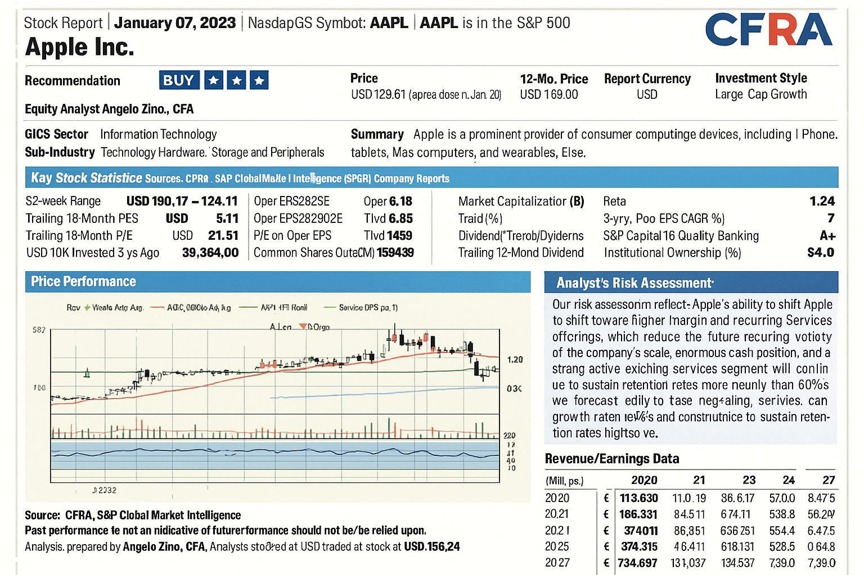
- Analysts, rating agencies, and portfolio managers interpret info for investors.
- Provide risk assessment, forecasts, and buy/sell recommendations.
- An example of financial analysts’ report

- Other Users
- Regulators, employees, labor unions and the general public interested in company performance and stability.

Forms of Business Organization
- Sole Proprietorship
  - A business owned by one person.
  - Owner makes all decisions and gets all profits, but also takes all risks (debts, losses).
  - Common for small family businesses (ex: local store).
- Partnership
  - A business owned by two or more people.
  - Partners share profits, losses, and responsibilities.
  - Often used by professionals like lawyers, doctors, CPAs.
- Corporation
- A separate legal entity (like its own “person” under the law).
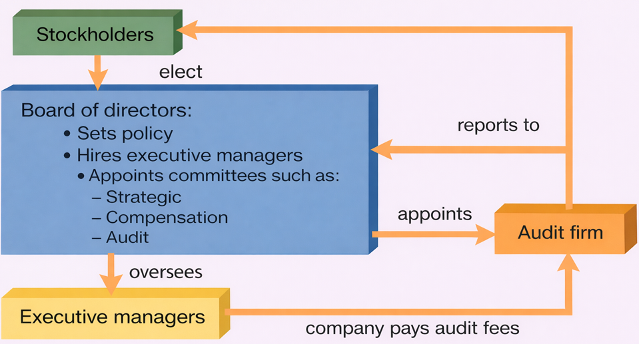
- Owned by shareholders who invest money in exchange for shares of stock.
- Shareholders usually don’t manage daily operations—that’s the managers’ job.
- Advantage: easy to raise money by selling stock, and owners have limited liability (they can only lose what they invested, not their personal assets).
- Disadvantage: Double taxation – corporate profits are taxed and when dividends are distributed, shareholders are taxed again.

Supplies of Information
- Supply of information: Companies disclose accounting info when benefits outweigh costs; factors like regulation and bargaining power influence how much is disclosed.
- U.S. public firms must file with SEC:
- 10-K = audited annual report. (e.g., Apple’s annual report.)
- 10-Q = unaudited quarterly report.
- Benefits of Disclosure
- Lowers cost of capital (cheaper debt/equity, higher stock prices).
- Helps in labor markets (recruiting talent).
- Improves supplier–customer relationships.
- Increases market awareness of company success.
- Costs of Disclosure
- Preparation & dissemination costs – auditing and SEC compliance is expensive.
- Competitive disadvantages – revealing strategies or innovations may erode advantage.
- Litigation risk – lawsuits from unmet expectations.
- Regulation Fair Disclosure (Reg FD)
- Adopted by the SEC to prevent selective disclosure to analysts or certain investors.
- Requires simultaneous public disclosure of material nonpublic information.
- Increased costs of voluntary disclosure and reduced selective advantages for firms.

Review Problems 1 – How Financial Statements are utilized by different user groups?
User of Financial Statement Information | Typical Question
_____ I. Managers and employees | - What product lines have performed well compared with competitors?
_____ II. Investment analysts and information intermediaries | - What expectations about the company’s future profit and cash flow should we use as input into the pricing of its stock?
_____ III. Creditors and suppliers | - Is the company in compliance with the contractual terms of its loan covenants?
_____ IV. Stockholders and directors | - Is company management demonstrating good stewardship of the resources that have been entrusted to it?
_____ V. Customers and strategic partners | - Is the strategic partnership providing reasonable returns to both parties?
_____ VI. Regulators and tax agencies | - What regulated price is appropriate given the company’s financial condition?

Business Activities
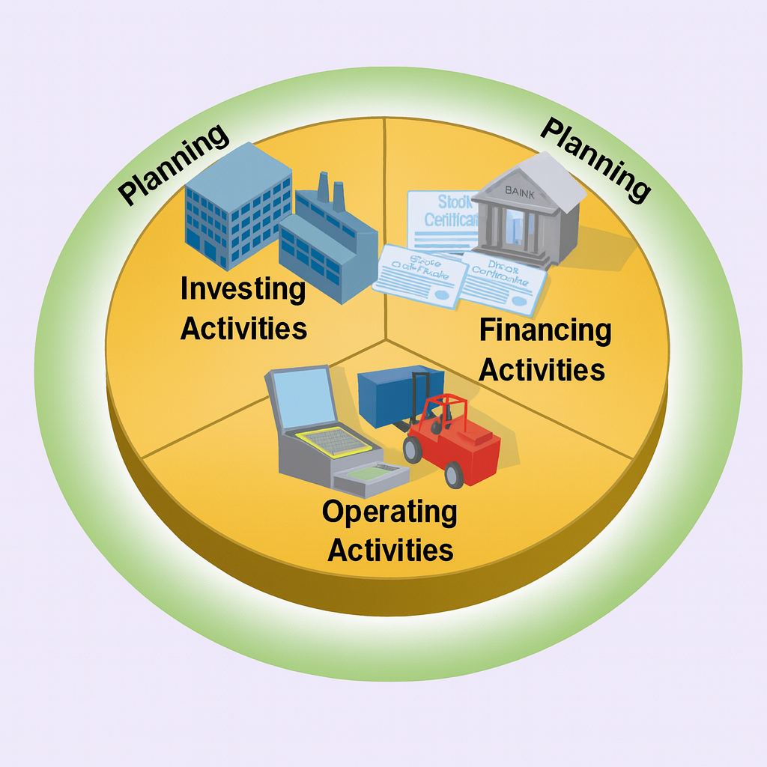
- A business organizes its efforts around three main types of activities: financing, investing, and operating. Together, these activities enable the business to achieve its primary objective — creating value and generating wealth.
- Financing Activities – obtaining funds from investors or owners (equity financing) and creditors (debt financing) to support the business.
- Exhibit 1.4 shows that firms use different mixes of credit and equity financing to support their operations, highlighting how financing strategies vary across companies.
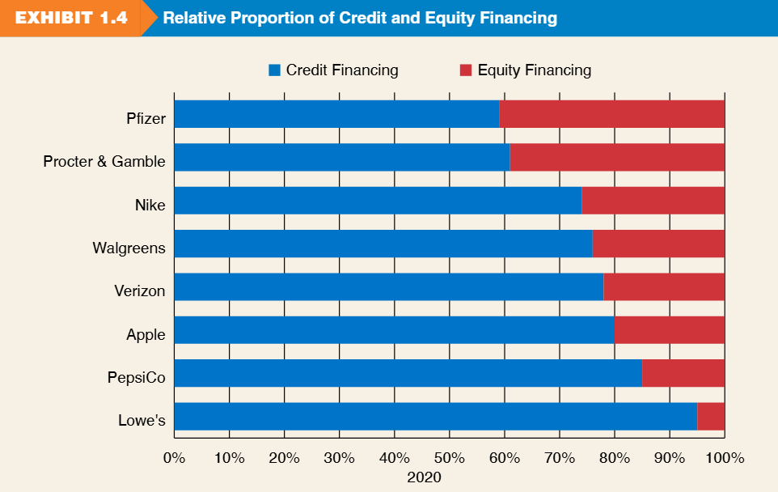
- Investing Activities – using those funds to acquire and manage resources (assets) needed for operations.

- Operating Activities – carrying out the day-to-day processes that produce goods or services and generate revenue.
- Inventory purchase
- Salary and Utility payments
- Sale of merchandise

Financial Statements and Accounting Duality
  - Companies summarize their business activities through four key financial statements, each serving a distinct purpose:
- Balance Sheet – shows the company’s investments (assets) and sources of financing
- Income Statement – reports the results of operations over a period.
- Statement of Stockholders’ Equity – details changes in equity (owner) financing.
- Statement of Cash Flows – explains the sources and uses of cash.

Accounting Duality : Assets = Obligations in a Balance Sheet
- When a new business begins operations, the first requirement is to raise capital.
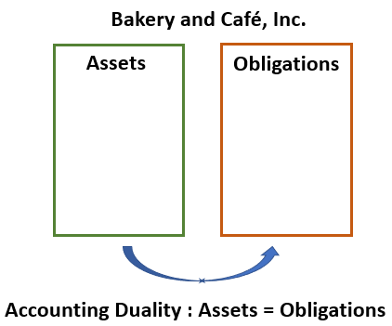
- For example, suppose Bakery and Café, Inc. receives a $20,000 investment from Madeleine, its sole owner (100% equity), and borrows $30,000 from a local bank.
- As a result, Bakery and Café, Inc. controls $50,000 in total assets, financed by two sources: lenders ($30,000 in liabilities) and the owner ($20,000 in equity).

- The company will use these assets to operate and generate profits. As the business grows and total assets increase, its obligations to fund providers (liabilities and equity) also increase by the same amount.
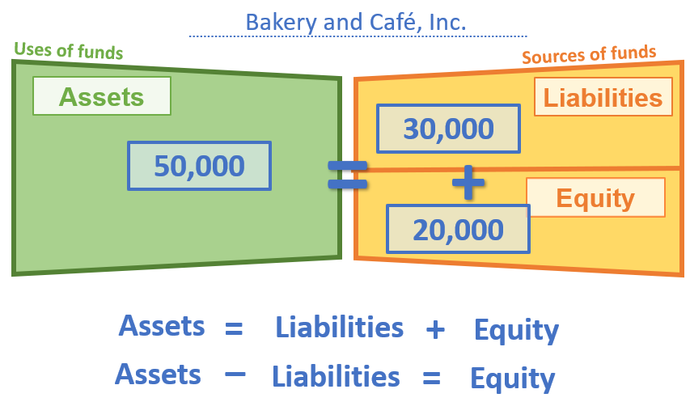
- At any point in time, there is a fundamental balance—assets on one side, and obligations on the other side—always equal in amount. This is the principle of duality.

- From the company’s perspective, obligations are of two types:
    - Liabilities — amounts owed to lenders.
    - Equity — amounts owed to investors.
- The diagram above illustrates the basic structure of the balance sheet: assets are reported on one side, while obligations (liabilities and equity) are reported on the other side according to their source of financing.

Review Problems 2 - Applying the Accounting Equation
Determine the missing amounts for each year below for Delta Air Lines, Inc., including the percentage of financing provided by owners and creditors.
($ millions) | Assets | Liabilities | Equity | % Financing by Owners | % Financing by Creditors
2019 | (1)? | $49,174 | $15,358 | (4)? | (5)?
2018 | $60,266 | (2)? | $13,687 | 23% | 77%
2017 | $53,671 | $41,141 | (3)? | 23% | 77%

Perspective Changes Everything
- There are always two sides to every story.

- For example: is someone buying a pineapple, or selling a pineapple?

- The answer depends on whose story the accountant is telling.

 | 

Entity Concepts
- A key principle in accounting is that your business is not you.

- For example, suppose Madeleine owns 100% of Bakery and Café, Inc.

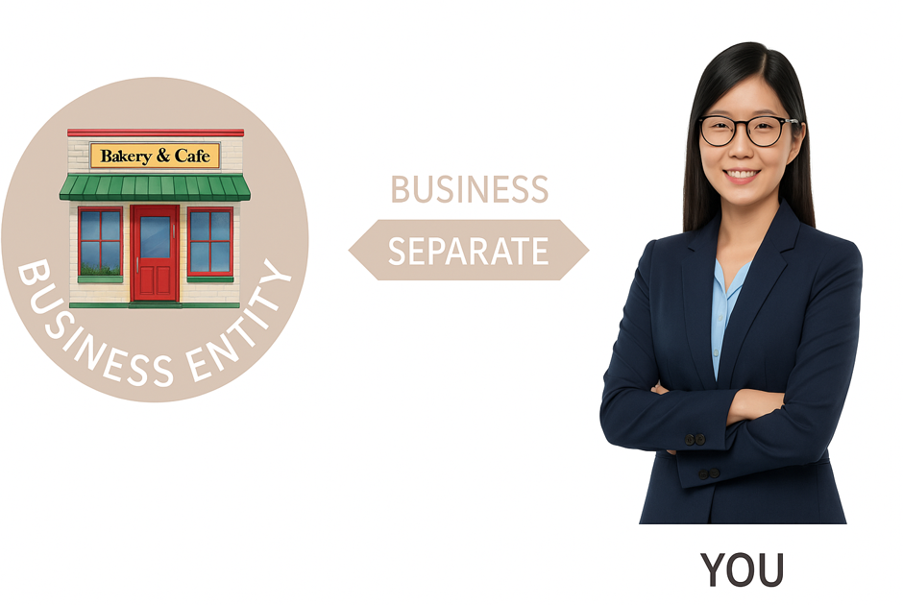
- Even though Madeleine is the sole owner, Madeleine and Bakery and Café, Inc. are two separate entities.
Madeleine

- From the business’s perspective, it has an obligation of $20,000 to its equity holder (Madeleine). In other words, accounting tells the story of the business, not of the owner in this case.

- When discussing the business entity, avoid phrasing such as “Madeleine has $20,000 of equity in Bakery and Café, Inc.” Such wording presents the information from Madeleine’s perspective rather than the company’s.
- Instead, when describing the business, it is more appropriate to say, “Bakery and Café, Inc. has a $20,000 obligation to Madeleine, the equity holder.” This maintains the proper entity-focused viewpoint in accounting.

How the Income Statement Flows into the Balance Sheet
- Please refer to the PowerPoint slide (1_Introduction to Accounting – Color Accounting MBA 620.pdf) to see how the income statement and balance sheet are connected.

- The equity section of the balance sheet includes retained earnings, which are referred below as generated equity), which are from the profit reported on the income statement.

- Retained earnings are the bridge linking the income statement to the balance sheet.

- The purple box in the diagram below illustrates the basic structure of the income statement, where profit equals revenue minus expenses.
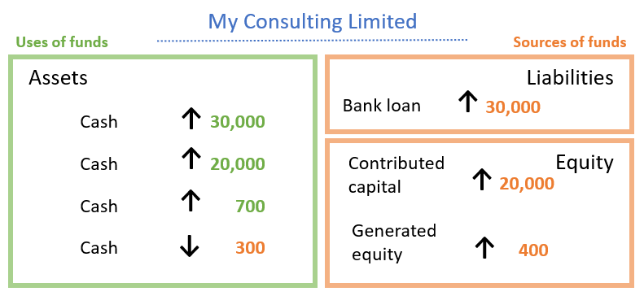
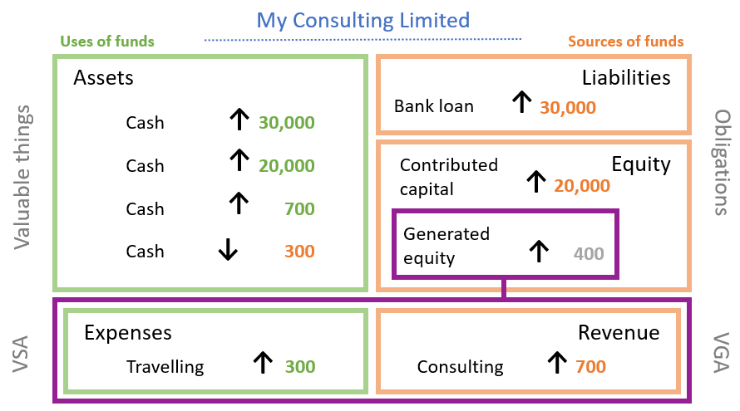

Illustration: The effect of “Double Taxation”
Taxed at both the corporate and shareholder levels (double taxation).
taxation.
Corporation (100% owned by “John”) |  |  | Proprietorship owned by “John”
Sales Revenue | $100 |  | Sales Revenue | $100
Expense | 60 |  | Expense | 60
Income Before Tax | 40 |  | Income Before Tax | 40
Tax (30%) by Corporation | (12) |  | Tax (30%) by Individual | (12)
Net Income (available to shareholders) | 28 |  | Cash Available to John, the owner | $28
Tax (15%) by shareholders | (4)
Cash Available to John,the shareholder | $24

Financial Statements – A Deep Dive
Balance Sheet (Statement of Financial Position)
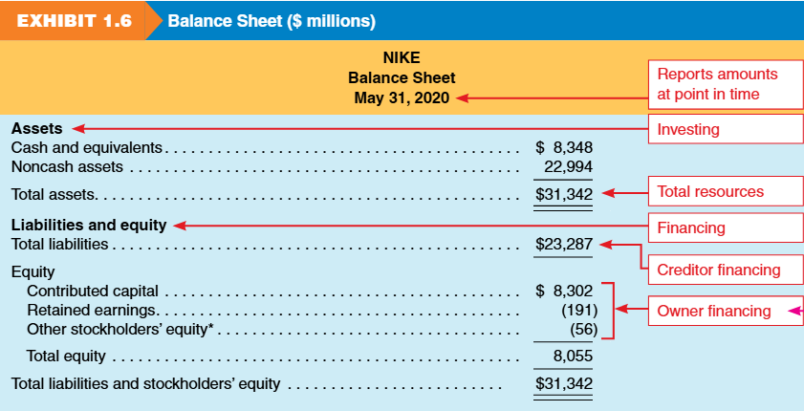
- A balance sheet reports on a company’s financial position at a point in time.

- It lists three elements: assets, liabilities, equity and sub-categories of each element.

- It summarizes the results of investing and financing activities.

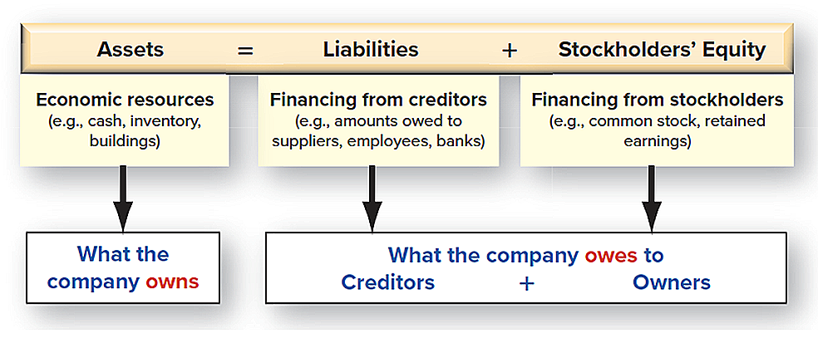
The Basic Accounting Equation – Balance Sheet
Income Statement Sheet
- The income statement reports the result of a company’s operating activities over a period of time.
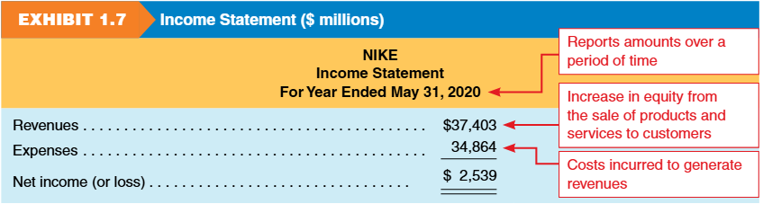
- It has many different names:
    - Statement of Earnings
    - Profit and Loss Statement (P&L)
    - Statement of Operations

- Income Statement Elements: Revenue and Expense
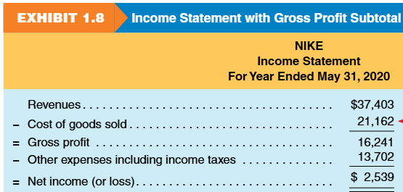
    - Revenue = equity increase from selling goods/services
    - Expense = cost to generate revenue.
    - Net income = revenues – expenses.
- Difference with balance sheet:
- Balance sheet = position at a point in time.
- Income statement = performance over a period of time.

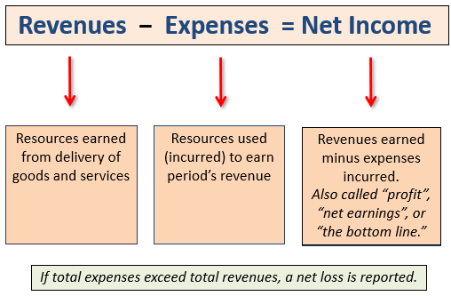
The Income Statement Equation
Statement of Stockholders’ Equity
- The statement of stockholders’ equity, or statement of equity, shows changes in equity accounts over time.
- Categories:
    - Contributed capital (common stock and paid-in capital)
      - net proceeds from issuing stock.
    - Retained earnings (cumulative net income/loss, minus dividends)
      - Also called earned capital accumulated income minus dividends.
      - Retained earnings link balance sheets through the income statement.
    - Other stockholders’ equity
- equity adjustments not included in income.
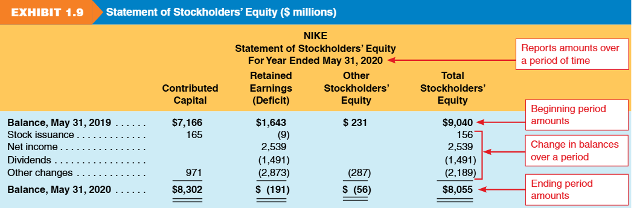
- In general, the Statement of Stockholder’s Equity is presented in two dimensions: vertical (changes over time) & horizontal (by category)

Statement of Cash Flows
  - The statement of cash flows reports net cash flows from operating, investing, and financing activities over a period of time.

  - Operating cash flow ≠ Net income due to timing differences in recognition vs cash collection/payment.

  - Both cash flow and net income are essential for decisions, reflecting different aspects of firm performance.
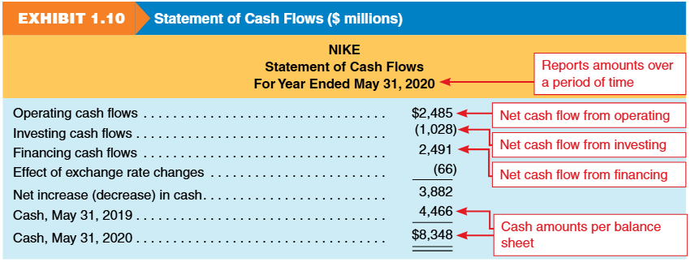

Information Beyond Financial Statements
- Management Discussion and Analysis (MD&A)
- Independent auditor report
- Financial statement footnotes
- Regulatory filings, including proxy statements and other SEC filings
- Environmental, Social, and Governance (ESG) reporting
- Nike’s 10-K Report (2024):
https://investors.nike.com/investors/news-events-and-reports/default.aspx

Articulation of Financial Statements
- How the statements connect (the Flow):
  - Income Statement yields Net Income.
  - Net Income flows into Statement of Equity (Retained Earnings).
  - Ending Equity flows into the Balance Sheet.
  - Change in Cash (Cash Flow Statement) matches Cash on Balance Sheet.
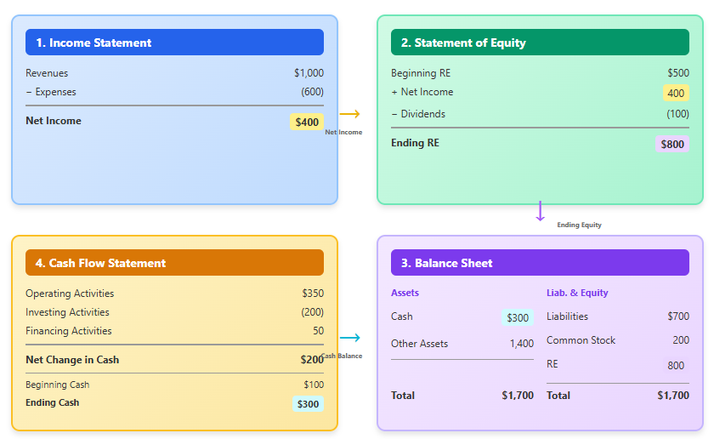
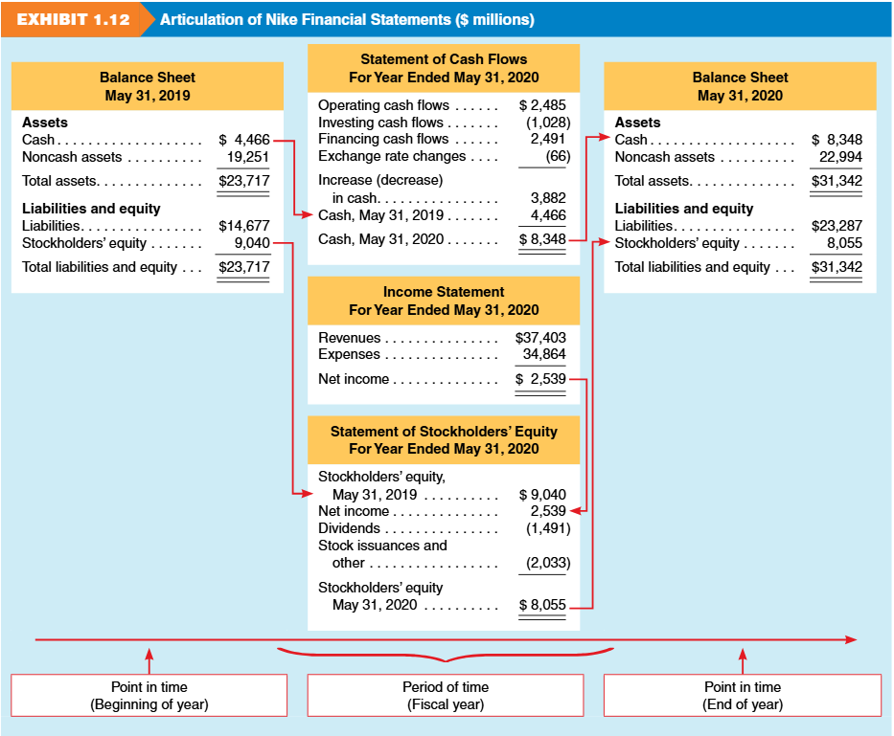
The illustration below (Ex 1.12) demonstrates how the four basic financial statements are interconnected.

Review Problems 3 - Samsung Electronics Financial Reporting Exercise

The following financial information is from Samsung Electronics, a competitor of Apple, for December 31, 2022 (in billions Korean won).
Item | Amount (₩ billions)
Short-term liabilities | 78,345
Cash flows used in financing | (19,928)
Revenues | 302,231
Stockholders' equity | 354,750
Cash flows from operations | 62,181
SG&A expenses | 68,813
Long-term assets | 229,954
Interest income | 3,064
Cost of goods sold | 190,042
Cash, beginning-year | 39,031
Provision for income taxes | (9,214)
Short-term assets | 218,471
Long-term liabilities | 15,330
Cash, ending year | 49,681
Cash flows used in investing | (31,603)

Required: Prepare an income statement and statement of cash flows for Samsung Electronics for the year ended December 31, 2022. Prepare Samsung Electronics’ balance sheet as of December 31, 2022.

Financial Reporting Enviroment
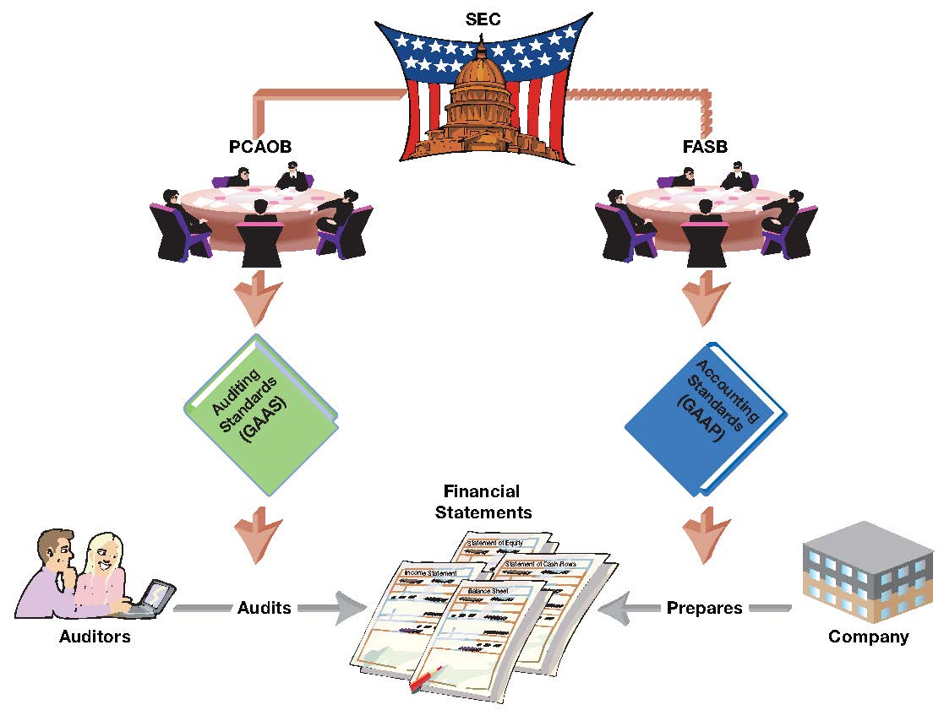
Regulation and Oversight
- The SEC (Securities and Exchange Commission, Securities Act of 1934)
- Regulates the issuance and trading of securities in the U.S.
- Companies with more than $10 million of assets and whose securities are held by more than 500 owners must file annual and other periodic reports with the SEC.

- FASB (Financial Accounting Standards Board) since 1973
- Establishes accounting standards in the U.S.
- Developed a Conceptual Framework to serve as a guide for accounting issues not covered by standards.

- SOX & PCAOB (Sarbanes-Oxley Act of 2002)
- Referred to as SOX by the accounting profession.
- Developed by Congress due to concerns over the quality of corporate financial reporting.
- Goal was to increase the level of confidence that external users have in financial statements.
- SOX established the Public Accounting Oversight Board (PCAOB) to approve auditing standards and to monitor the quality of financial statements and audits.

Management, Auditors, and Financial Statements
- Management
- Prepares the financial statements.
- Takes responsibility for what is disclosed in the financial statements.

- Independent Auditors
- “Audit” financial statements.
- As assurance of accuracy and completeness, financial statements of publicly traded companies must be audited by an independent audit firm.
- An audit opinion is not a guarantee.

A Global Perspective – International Accounting Standards
- Globalization of capital markets and diversity in international accounting principles created a need for greater comparability of financial information across countries.
- The International Accounting Standards Board (IASB) oversees the development of accounting standards for countries outside the United States.
- Over 100 countries, including all European Union members, mandate the use of International Financial Reporting Standards (IFRS) developed by the IASB.

- Key Standard-Setting Bodies
- FASB (Financial Accounting Standards Board) – Issues U.S. GAAP.
- IASB (International Accounting Standards Board) – Issues IFRS, used by 100+ countries (e.g., EU, UK, Canada, Japan).

- GAAP vs. IFRS
- GAAP (Generally Accepted Accounting Principles) – U.S.-based standards.
- IFRS (International Financial Reporting Standards) – Global standards outside the U.S., aiming for comparability.
- Both frameworks produce the same financial statements (Balance Sheet, Income Statement, Cash Flows, Equity), but differ in details and treatments.

- Why Global Standards Matter
- Improve quality and transparency of financial reports.
- Benefit investors, companies, and markets through comparability.
- Reduce costs for preparers and users of financial statements.
- Make global capital markets more efficient.

- Comparability and Convergence
  - Since 2007, the SEC allows foreign companies to file IFRS financials without reconciling to U.S. GAAP.
  - Over 500 companies with trillions in market cap file IFRS reports to the SEC.
  - Past convergence projects (FASB + IASB) worked on areas like leases, revenue recognition, and financial instruments.
  - Currently, no active convergence projects, but comparability remains a goal.
  - At a broad level, IFRS ≈ GAAP → both use accrual accounting, similar concepts, and frameworks.
  - Differences remain in accounting treatments.

Review Problems 4 - Roles in the Development and Regulation of Financial Reporting
Match each of the following terms with the most appropriate explanation of its relationship to financial reporting.
Terms: (a) Auditor, (b) FASB, (c) GAAP, (d) Internal controls, (e) Management, (f) PCAOB, (g) SEC
1. _____ Set of authoritative standards and accepted practices that guide the preparation of financial statements in the U.S.
2. _____ Organization that has the ultimate authority over financial reporting.
3. _____ Currently codifies new accounting standards that guide financial reporting.
4. _____ Approves auditing standards and monitors audits of public companies that are required to report annual results.
5. _____ Takes responsibility for the accuracy and completeness of information disclosed in the financial statements.
6. _____ Provides an opinion on the fair presentation of a company’s financial reporting.
7. _____ Helps ensure the accuracy of a company’s financial reporting through a system of internal monitoring procedures and rules.

Analyzing Financial Statements
- Financial statements show a company’s financial health and performance but need interpretation.
- Raw figures (e.g., net income or liabilities) are not meaningful without context.
- Analysts use ratios to interpret data, compare firms, and spot trends.
- Ratios also help identify risks and profitability across companies of different sizes.

Profitability Analysis
- A key measure: Return on Equity (ROE), which compares net income to equity used to generate it.
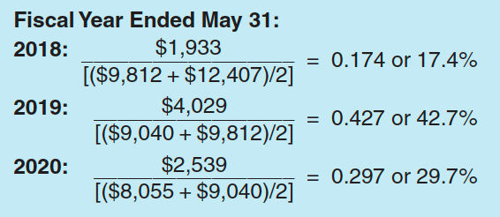
- Analysis Objective
  - To assess a firm’s ability to generate returns for stockholders.
  - ROE = Net income ÷ Average stockholders’ equity ((beginning + ending ÷ 2)
  - Applying ROE to Nike
  - Guidance: ROE > 10% (and rising) indicates strong and sustainable returns.
- Takeaways
  - Nike achieved exceptional ROE: 42% in 2019, nearly 30% in 2020.
  - These exceed competitors (Adidas, Under Armor).
  - High ROE indicates strong shareholder returns.
  - Nike must continue product innovation to preserve leadership.
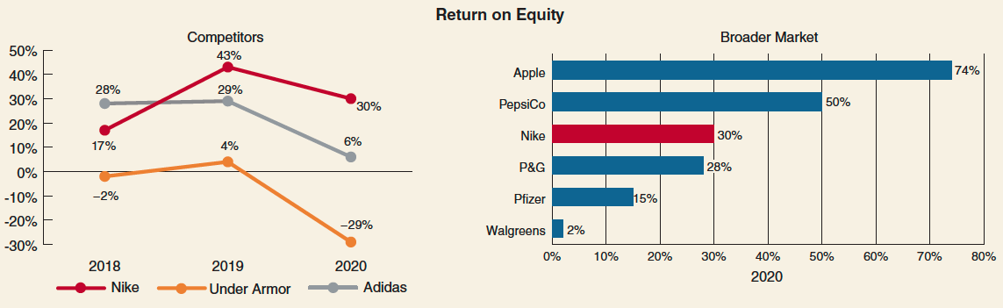
Credit Risk Analysis
- Analysts often assess the risk associated with investing in or lending to a company.
- Higher risk usually leads to higher expected returns, but also greater uncertainty.
- One important factor of risk is long-term solvency, measured by the debt-to-equity (D/E) ratio.

- Analysis Objective
- The goal is to evaluate a company’s ability to meet its debt obligations (interest and principal payments).
- Analysis Tool
- Debt-to-Equity Ratio = Total Liabilities ÷ Total Stockholders’ Equity.
- Applying the Debt-to-Equity Ratio to Nike
- 2018: 1.30 (Liabilities $12,724 / Equity $9,812).
- 2019: 1.62 (Liabilities $14,677 / Equity $9,040).
- 2020: 2.89 (Liabilities $23,287 / Equity $8,055).
- Guidance
- Solvency depends on how much a company relies on creditor financing.
- Higher D/E ratios increase the risk of bankruptcy due to heavier interest and debt obligations.
- Takeaways
- - Nike’s D/E ratio increased significantly over three years, with liabilities rising faster than equity.
- - By 2020, Nike’s D/E ratio surpassed competitors, supporting its higher ROE through increased debt financing.
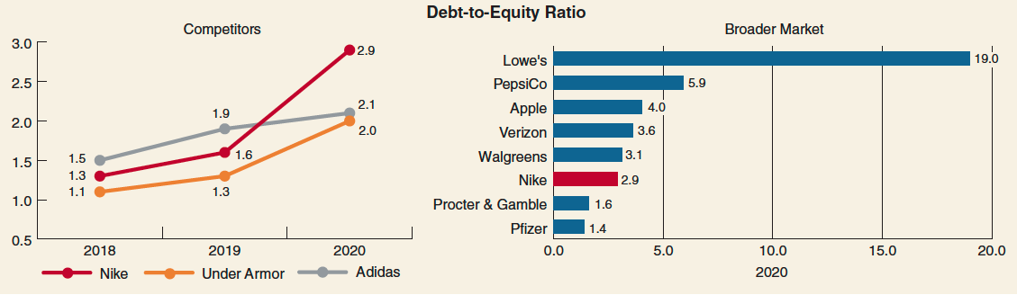

Review Problems 5 - Adidas Financial Analysis
Adidas, a major competitor of Nike, markets athletic shoes and apparel under the Adidas and Reebok brands. It also sells Solomon ski equipment and TaylorMade golf equipment. The following information is from Adidas’s 2019 financial statements (Adidas’s financial statements are reported in Euros, the currency of the European Union):
(millions) | Adidas
Net income (loss) (2019) | € 1,977
Stockholders’ equity (2019 year-end) | 7,058
Stockholders’ equity (2018 year-end) | 6,364
Total liabilities (2019 year-end) | 13,622

Required :
a. Calculate the 2019 return on equity (ROE) ratio for Adidas.
b. Calculate the 2019 debt-to-equity ratio for Adidas.
c. Compare the profitability and risk of Adidas to that of Nike. Note: In your analysis, compare FY 2020 statements of Nike (12 months ended May 31, 2020) to 2019 statements of Adidas (12 months ended December 31, 2019).

Homework Assignments

E1.23 The Balance Sheet Equation. The Arcadia Company reported the following financial results during its first two years of operations:

Year End | Assets | = | Liabilities | + | Shareholders’ Equity
Year 1 . . . | $90,000 | = | $50,000 | + | $40,000
Year 2 . . . | 75,000 | = | 30,000 | + | 45,000

Assuming that no dividends were paid or declared and that no additional capital was invested in Year 2, deter- mine Arcadia’s net income (or loss) for Year 2.

E1.26 Key Relations: Revenues, Expenses, Dividends, and Retained Earnings. Compute the missing amounts in the following table. (At the end of Year 3, retained earnings was $7,296.) Comment on the company’s performance over the three-year period after calculating the relationship of expenses as a percentage of revenues and net income as a percentage of revenues. Do you agree with the company’s dividend policy? Why?

 | Year 1 | Year 2 | Year 3
Retained earnings (beginning) . . . . . | $3,450 | $3,430 | $3,120
Revenues . . . . . . . . . . . . . . . . . . . . . . | 5,480 | 5,540 | ?
Expenses . . . . . . . . . . . . . . . . . . . . . . | ? | 5,600 | 5,700
Dividends . . . . . . . . . . . . . . . . . . . . . . | 0 | ? | 14

P1.30 Key Financial Statement Relations: Balance Sheet, Income Statement, and Statement of Cash Flows. Compute the missing amounts in the following financial statements. You may assume that accounts receivable relate only to credit sales and that accounts payable relate only to credit purchases of inventory. There were no sales of property and equipment during Year 2 and any purchases of property and equipment were made using cash. Assume that there is no gain or loss on the sale of the land. What is your assessment of the company’s financial performance in Year 2?

Balance Sheet at | December 31, Year 1 | December 31, Year 2
Assets
Cash . . . . . . . . . . . . . . . . . . . . . . . . . . . . . . . . . . . . . | $ ? | $ 7,000
Marketable securities . . . . . . . . . . . . . . . . . . . . . . . . . | 3,000 | 7,000
Accounts receivable . . . . . . . . . . . . . . . . . . . . . . . . . . | 12,000 | 32,000
Merchandise inventory . . . . . . . . . . . . . . . . . . . . . . . . | 52,000 | 18,000
Prepaid advertising. . . . . . . . . . . . . . . . . . . . . . . . . . . | 15,000 | 17,500
Total current assets . . . . . . . . . . . . . . . . . . . . . . . . . . | 92,000 | 81,500
Property, plant, and equipment, (net) . . . . . . . . . . . . . | ? | 237,000
Land . . . . . . . . . . . . . . . . . . . . . . . . . . . . . . . . . . . . . . | 15,000 | ?
Intangible assets. . . . . . . . . . . . . . . . . . . . . . . . . . . . . | ? | 9,000
Total assets. . . . . . . . . . . . . . . . . . . . . . . . . . . . . . . . . | $258,000 | $339,500
Liabilities
Accounts payable . . . . . . . . . . . . . . . . . . . . . . . . . . . . | $ 12,000 | $ 23,000
Wages payable . . . . . . . . . . . . . . . . . . . . . . . . . . . . . . | ? | 30,000
Interest payable . . . . . . . . . . . . . . . . . . . . . . . . . . . . . | 6,000 | 2,500
Dividends payable . . . . . . . . . . . . . . . . . . . . . . . . . . . | 3,000 | ?
Taxes payable. . . . . . . . . . . . . . . . . . . . . . . . . . . . . . . | 17,000 | 12,000
Total current liabilities . . . . . . . . . . . . . . . . . . . . . . . . . | 43,000 | 81,500
Long-term debt . . . . . . . . . . . . . . . . . . . . . . . . . . . . . . | ? | 61,000
Shareholders’ equity
Common stock . . . . . . . . . . . . . . . . . . . . . . . . . . . . . . | 150,000 | 180,000
Retained earnings . . . . . . . . . . . . . . . . . . . . . . . . . . . | 23,000 | 32,000
Treasury stock . . . . . . . . . . . . . . . . . . . . . . . . . . . . . . | (10,000) | ?
Total shareholders’ equity . . . . . . . . . . . . . . . . . . . . . . | 163,000 | 197,000
Total liabilities and shareholders’ equity . . . . . . . . . . . | $258,000 | $339,500

Income Statement for Year Ending | December 31, Year 2
Sales revenue. . . . . . . . . . . . . . . . . . . . . . . . . . . . . . . . . . . . . . . . . | $ ?
Cost of sales. . . . . . . . . . . . . . . . . . . . . . . . . . . . . . . . . . . . . . . . . . | 170,000
Gross profit. . . . . . . . . . . . . . . . . . . . . . . . . . . . . . . . . . . . . . . . . . . | 110,000
Expenses:
Wages . . . . . . . . . . . . . . . . . . . . . . . . . . . . . . . . . . . . . . . . . . . . . . | 30,000
Advertising . . . . . . . . . . . . . . . . . . . . . . . . . . . . . . . . . . . . . . . . . . . | 1,500
Depreciation . . . . . . . . . . . . . . . . . . . . . . . . . . . . . . . . . . . . . . . . . . | 3,000
Amortization . . . . . . . . . . . . . . . . . . . . . . . . . . . . . . . . . . . . . . . . . . | 2,000
Total expenses . . . . . . . . . . . . . . . . . . . . . . . . . . . . . . . . . . . . . . . . | 36,500
Operating profit. . . . . . . . . . . . . . . . . . . . . . . . . . . . . . . . . . . . . . . . | 73,500
Interest . . . . . . . . . . . . . . . . . . . . . . . . . . . . . . . . . . . . . . . . . . . . . . | ?
Income (loss) before taxes . . . . . . . . . . . . . . . . . . . . . . . . . . . . . . . | 70,000
Tax expense . . . . . . . . . . . . . . . . . . . . . . . . . . . . . . . . . . . . . . . . . . | ?
Net income . . . . . . . . . . . . . . . . . . . . . . . . . . . . . . . . . . . . . . . . . . . | $ 45,000

Statement of Cash Flows for Year Ended | December 31, Year 2
Cash flows from operating activities
Cash collections from customers . . . . . . . . . . . . . . . . . . . . . . . . . . | $ 260,000
Cash payments for:
Inventory. . . . . . . . . . . . . . . . . . . . . . . . . . . . . . . . . . . . . . . . . . . . . | (125,000)
Wages . . . . . . . . . . . . . . . . . . . . . . . . . . . . . . . . . . . . . . . . . . . . . . | (5,000)
Taxes . . . . . . . . . . . . . . . . . . . . . . . . . . . . . . . . . . . . . . . . . . . . . . . | (30,000)
Interest . . . . . . . . . . . . . . . . . . . . . . . . . . . . . . . . . . . . . . . . . . . . . . | (7,000)
Advertising . . . . . . . . . . . . . . . . . . . . . . . . . . . . . . . . . . . . . . . . . . . | ?
Net cash provided by operations . . . . . . . . . . . . . . . . . . . . . . . . . . | 89,000
Cash flows from investing activities
(Purchases) sale of property, plant and equipment . . . . . . . . . . . . | (100,000)
(Purchase) sale of marketable securities . . . . . . . . . . . . . . . . . . . . | ?
(Purchase) sale of land. . . . . . . . . . . . . . . . . . . . . . . . . . . . . . . . . . | 3,000
Net cash provided by investing activities . . . . . . . . . . . . . . . . . . . . | (101,000)
Cash flows from financing activities
Issuance (repayment) of long-term debt. . . . . . . . . . . . . . . . . . . . . | 9,000
Payment of dividend . . . . . . . . . . . . . . . . . . . . . . . . . . . . . . . . . . . . | (25,000)
Issuance (repurchase) of common stock . . . . . . . . . . . . . . . . . . . . | ?
(Purchase) sale of treasury stock. . . . . . . . . . . . . . . . . . . . . . . . . . | (5,000)
Net cash provided by financing activities . . . . . . . . . . . . . . . . . . . . | 9,000
Change in cash. . . . . . . . . . . . . . . . . . . . . . . . . . . . . . . . . . . . . . . . | $ ?

------------------------------------------------ The End of Chapter 1 ---------------------------------------------

Please see page 8 for double taxation numerical example.

